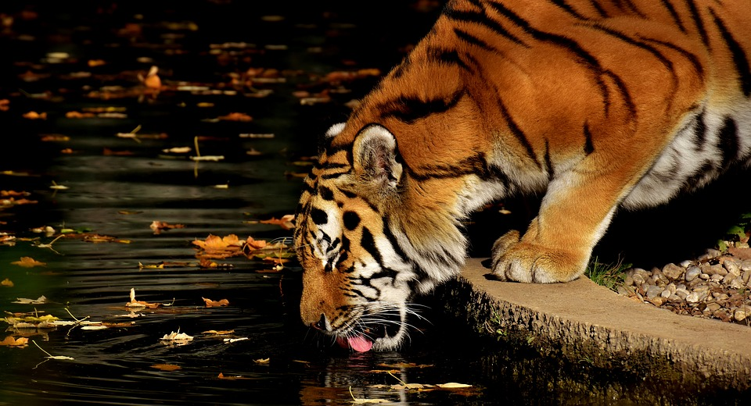

SAVE THE TIGERS MODEL HORSE SHOW

S

Save the Tigers Model Horse Show Information and Rules

Where and When:

Saturday March 24th 2018. The show hall will open for set up starting at 7:00am. Judging will start at 8:15am.

The show is located at the Ganyard Building at the Franklin County Fairground in Hilliard, OH.

5035 Northwest Parkway
Hilliard, OH 43026

Parking:
There is a lot located outside of the building that will be available for parking. There is a small area outside the front door that can be used for unloading, however; cars must be moved once unloading is completed.

NAMHSA:
The show is pending approval and the class list has been made following NAN standards.

Entry:
There are a total of 57 spots available and they will be given away on a first come first serve basis. Each entrant will receive a full table. The entry fee will be $50 for the Open Division and $30 for the Novice Division. The entry form can be found on the Information page on the show’s website. Entry fees can either be mailed in or completed via PayPal by sending to wildlifeshowseries@outlook.com . If completed through PayPal, please make sure to send your entry form by email to wildlifeshowseries@outlook.com or mail to:
Kristen Donato
24 Murphy’s View Place
Powell, OH 43065
Entries must be received by March 14th. Spots will not be held without a paid entry fee. Refunds will not be available.

Judges:
OF Breyer/Other Plastic Breed and Collectability - Silke Brockmoeller
Limited Run Breyer Breed and Collectability- Tonjia Clark
Peter Stone - TBD
Limited Run Peter Stone – TBD
Custom (breed and workmanship?) - Mandy Yontz
O.F Mini (breed and collectability?) - Lynn Rhea
Novice – TBD
Artist Resin (breed and workmanship) - Karen Dietrich
Performance – Maureen Reynolds

Etiquette and Show Hall Rules:

- Please maintain a courteous and positive attitude towards the other contenders at the show.
- If an issue arises, please contact the show holder (Kristen Donato) in order to help find a solution.
- The judging is final. Please do not argue or contest the judge’s decisions. Questions may be asked only if they are to serve the purpose of learning more about showing.
- While judging is going on, please refrain from standing by the tables.
- There should be no running or yelling in the show hall.
- Appropriate language should be used (i.e. no cursing or inappropriate topics)
- Absolutely no alcohol or smoking is allowed on the property.
- Please do not touch another person’s model without their permission. If you break a model, you buy it.
- Sales are permitted, however; they must be done at your table and can not block pathways.
- The Show Holder reserves the right to ask anyone not following these rules to leave the show. No refund will be given for entrants that are asked to leave.

Show Rules
- Each entrant is welcome to enter all divisions within the division they have entered.
- This show will be double-judged for Breed and Collectability/Workmanship
- The Open Divisions includes Original Finish Breyer/Other (like Copperfox), Original Finish Peter Stone, Original Finish Mini, Artist Resin, Custom, and Performance.
- Each class is limited to THREE models per entrant, however additional models may be entered by placing a dollar next to the extra horse.
- The mini division is reserved for Breyer Stablemates and Mini Whinnies, Peter Stone Chips, and any other model horse that is of similar size.
- Custom Minis should be shown in the custom division under the Custom Minis Section
- Custom Glazed China should show in the Custom Division
- If your horse is a cross between two breeds in different sections, select the “Other Part/Pure” class of the section that the mold most resembles.
- Horses will be placed from 1st through 6th place with the 1st and 2nd place horses receiving NAN cards.
- Satin Ribbons will be awarded to 1st and 2nd place horses and paper ribbons will be awarded to 3rd-6th place.
- Each Division will have an Overall Champion and Overall Reserve Champion.
- If your horse is an uncommon breed or color, please provide documentation. Please limit the size to an 8.5” x 11” piece of paper.
- Tags should be placed breed and gender side up. Judges can disqualify horses with incorrect tags.
- Judges can not judge horses that they have worked/collaborated on.
- Judges cannot enter their own division, however, they may enter other divisions.
- Judges will be allowed to split classes if necessary.
- I have tried to include a spot for every horse and breed but if you have any questions about where your horse should go, please feel free to contact me at wildlifeshowseries@outlook.com or you can ask me or one of the judges at the show

Tags: Each model requires a toe tag. A horse without a tag can be disqualified at the Judge’s discretion. The tags can be any color as long as the writing is easily visible. Tags should be string tags attached to the legs of the horses. They should be the 1 3/4th x 1 3/32nd tag size. On the front of the tag should be the horse’s breed and gender (this side should be turned up when the horse is placed on the table for judging). On the back side should be your horses name and your initials. The following abbreviations are acceptable:

S = Stallion
M = Mare
F = Filly
G = Gelding
C = Colt
TB = Thoroughbred
WB = Warmblood
NSH = National Show Horse
MFT = Missouri Fox Trotters
TWH = Tennessee Walking Horse
ASB = American Saddlebred

Collectability:
Due to popular demand, collectability is now a part of the show. In order for your horse to be considered for collectability, the horse must be accompanied with a description explaining why it is collectible. Please include where the horse was available from and the run number for the model, as well as any other information you’d like to include to further showcase the collectability of your model.

Show Duration:
Every attempt will be made to keep the show going at a fast pace in order to make sure the show does not continue for an excessive amount of time despite the show’s large size and many divisions. There is not a scheduled time for the show to end.

Lunch:
Once a stopping point is able to be reached, we will break for lunch for approximately 45 minutes. There are local restaurants within driving distance of the show. There will be a list of restaurants available on the website under the travel section.

Fun classes:
There are 5 fun classes being offered at the show and are open to anyone to join. These classes will not be NAN-qualified and solely serve the purpose of fun. The fun classes will be held when an open ring is available for them at the show. An announcement will be made when the fun classes are ready to begin.

Raffle:
There will be a raffle the day of the show in order to help raise additional funds to send to the rhinos. Each entrant will be given three raffle tickets for free. Additional Raffle tickets may be purchased with $1.00 for one ticket or $5.00 for six tickets. The winners will be drawn after the break for lunch (or during if everyone is back and there’s a consensus). All Donations are welcome for the raffle! If you have something you’d like to donate, please indicate on your entry form, or you can contact me directly at wildlifeshowseries@outlook.com

If you have any additional questions please feel free to ask, especially if this is your first show! I am more than happy to help! Contact me at wildlifeshowseries@outlook.com

